

|  |  |  |  |  |  |  |  |  |
| --- | --- | --- | --- | --- | --- | --- | --- | --- |
|  | | | | | | | | |
|  | | 1CWK100 – Web Services Project | | | | |  | |
|  |  | | | | | | |  |
|  | | | |  |  | | | |
|  | | | | Nicholas Higson |  | | | |
|  | | | | January 2021—Enterprise Programming |  | | | |
|  | | |  | | |  | | |

**Sections Completed**

|  |  |
| --- | --- |
| **Criteria 1**  Access to the data using simple http web service calls (10 marks) | Full implementation. Working persistent storage, all CRUD methods working. |
| **Criteria 2**  Options to return the data in text, json (the default) or xml (10 marks) | Use of standard libraries to create formatting for JSON, XML, and String data. |
| **Criteria 3**  Google App Engine or Microsoft Azure to implement the application on a remote cloud based server. (20 marks) | Fully tested and demo’d CRUD operation on cloud server. Later encountered documented errors. |
| **Criteria 4**  A WSDL description of the interface to the web service (5 marks) | Attempt made to create WSDL interface, encountered errors. |
| **Criteria 5**  Access to the data using REST type interaction (10 marks) | No real attempt made. |
| **Criteria 6**  An Ajax based web front end to retrieve the data and display in a suitable format using library based routines for an enhanced user interface (15 marks) | Ajax standard library used. jQuery implemented throughout. |
| **Criteria 7**  Critical analysis of your work and the techniques you have used. (30 marks) | Separate report for critical analysis submitted. |

**Introduction**

This report details the development, deployment, and publishing of a Film information web service. The web service was initially developed and tested locally and has since been deployed to the cloud.

The aim of this report is to show the function of the service, and the work done to meet the criteria. It will also demonstrate the implementation of the cloud service.

This will be achieved using annotated screenshots. Following the proof of work, analysis on techniques used will follow.

The screenshots will show localhost as at the time of taking and collating, the cloud deployment was not working. This has since been resolved, displayed by the final screenshot.

App can be accessed at https://clean-respect-301812.appspot.com/

**Screenshots**

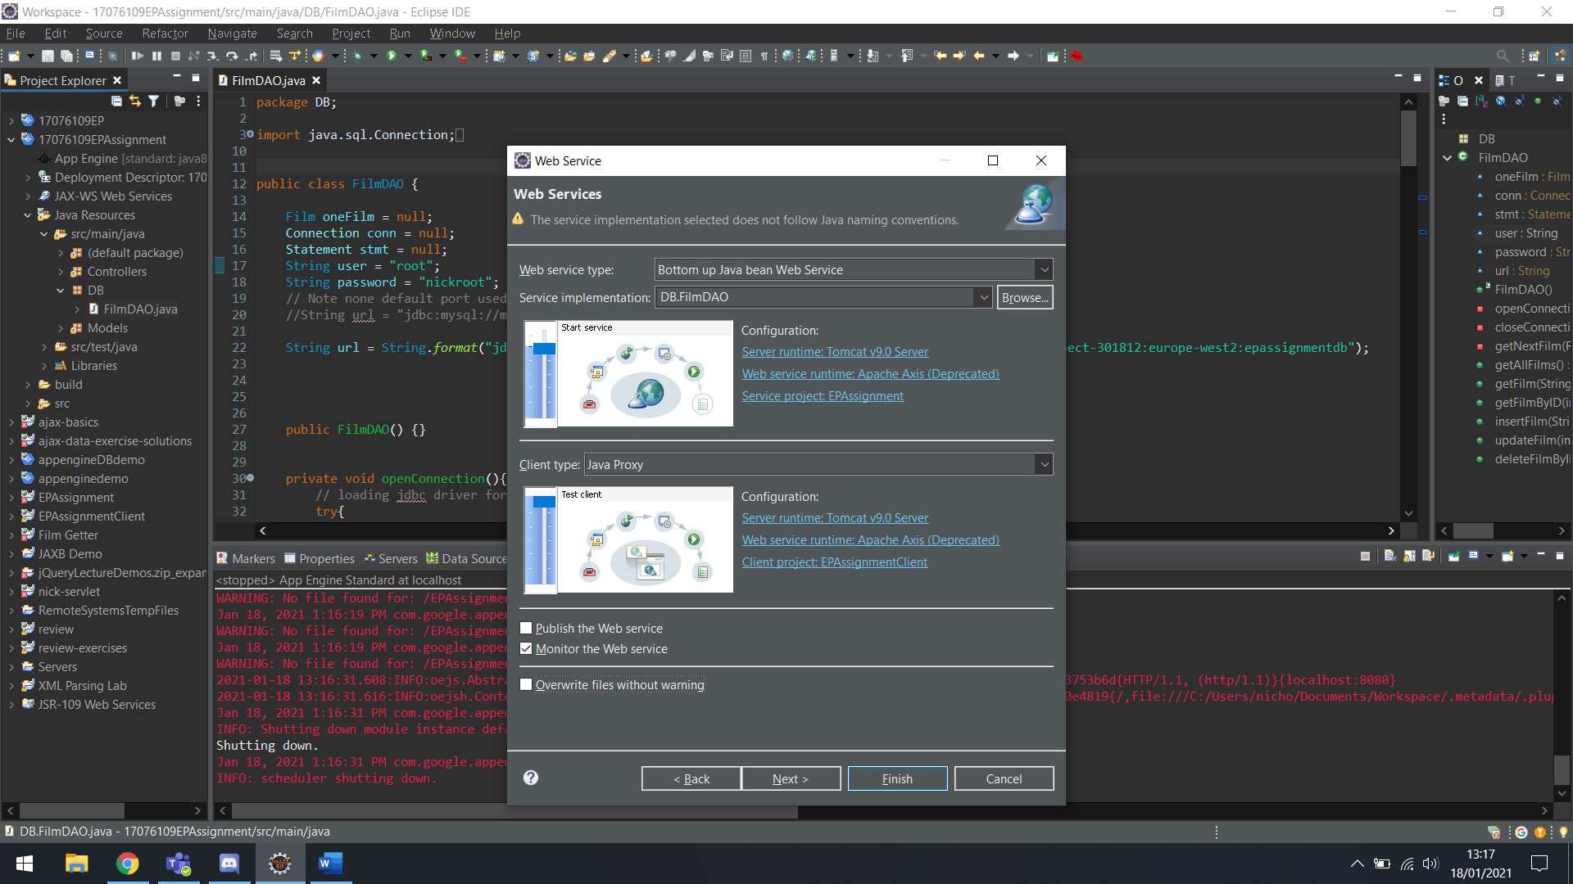

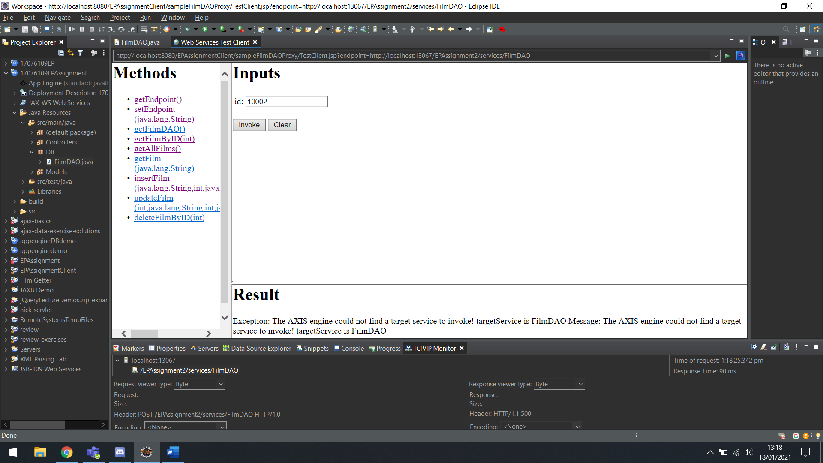

Attempt to implement WSDL.

**Get All Films**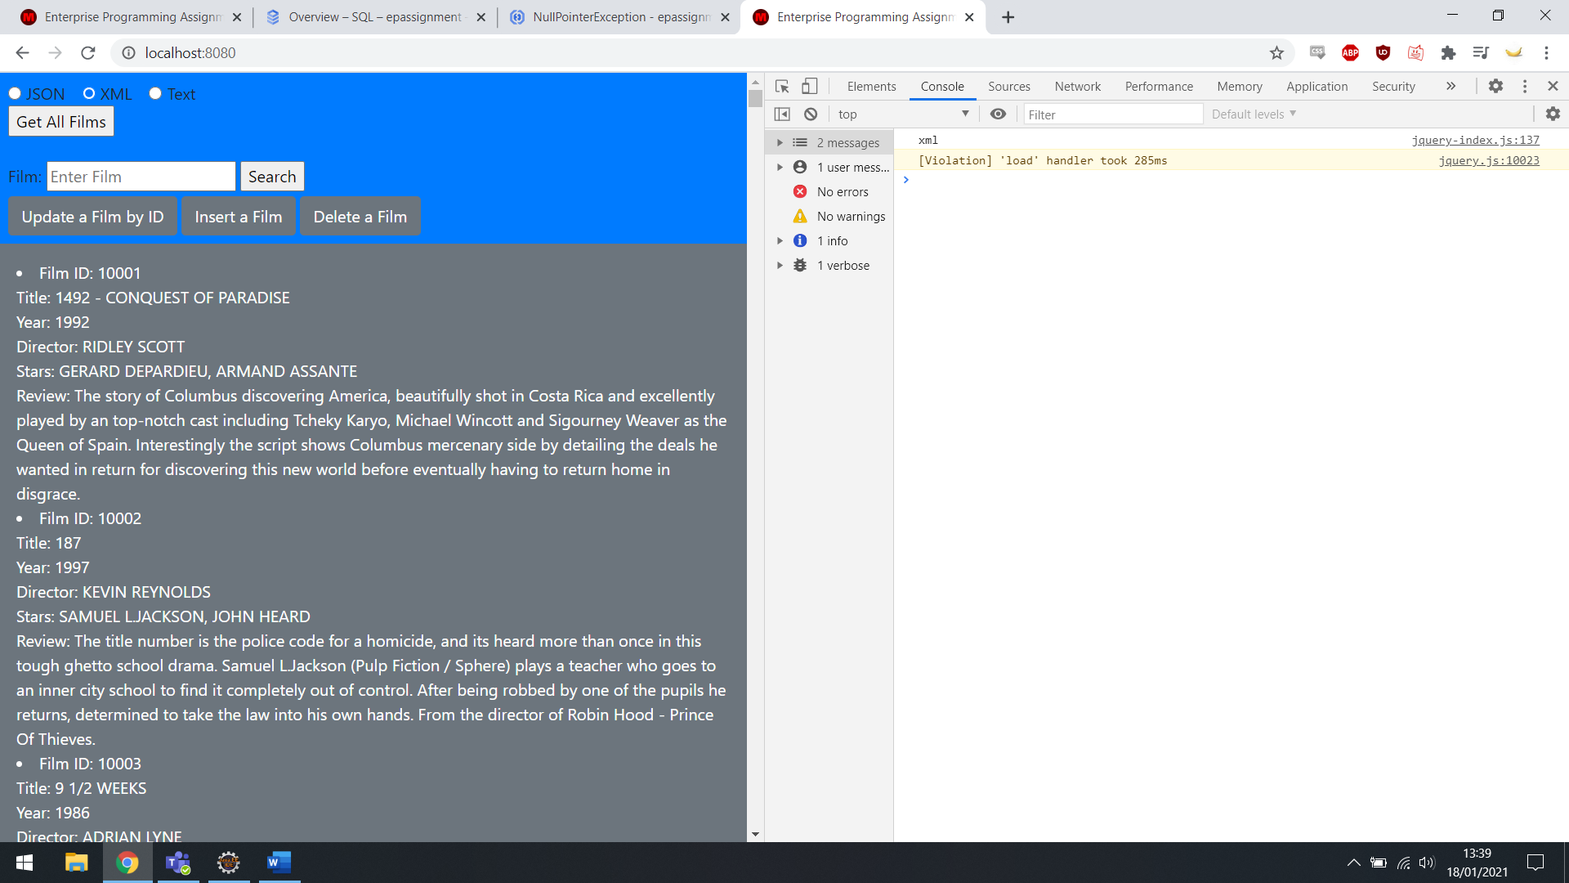XML Output of Get All Films

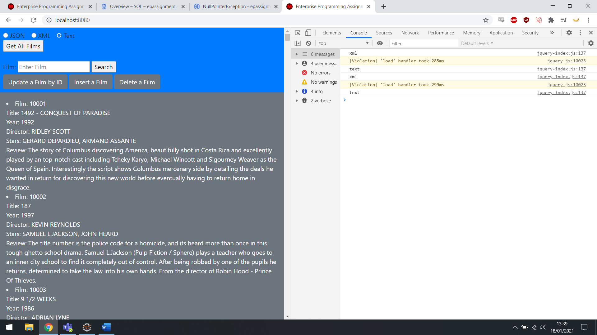 Text Output of Get All Films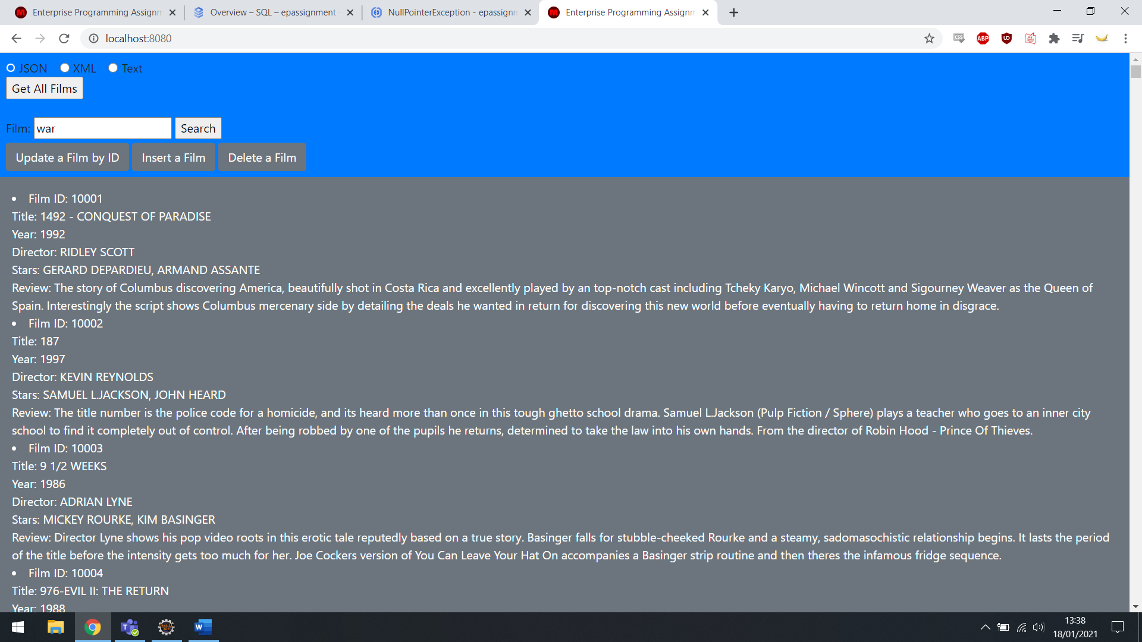

JSON Output of Get All Films

**Get Film by Name**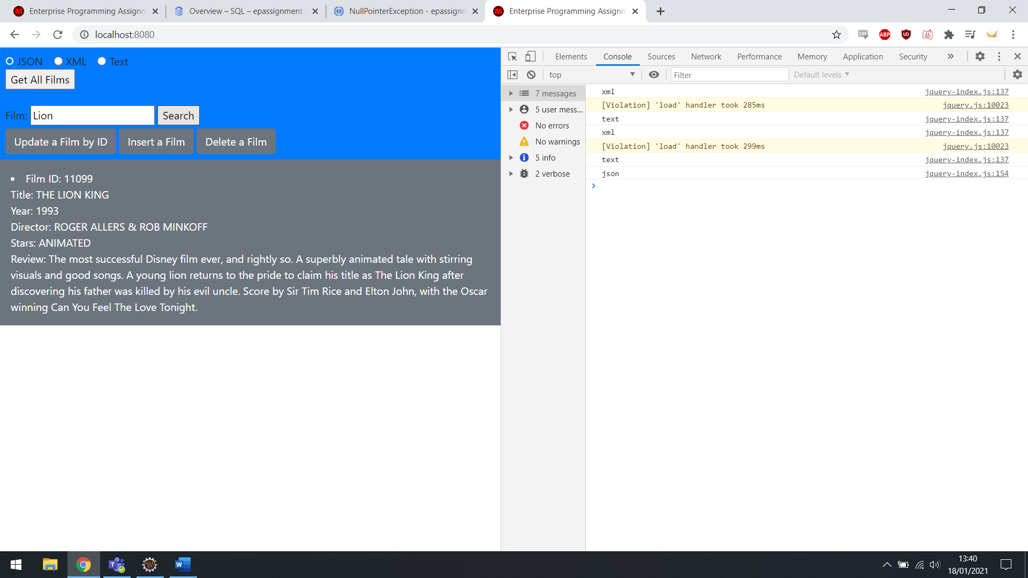JSON Output of Get Film, searched by Lion.

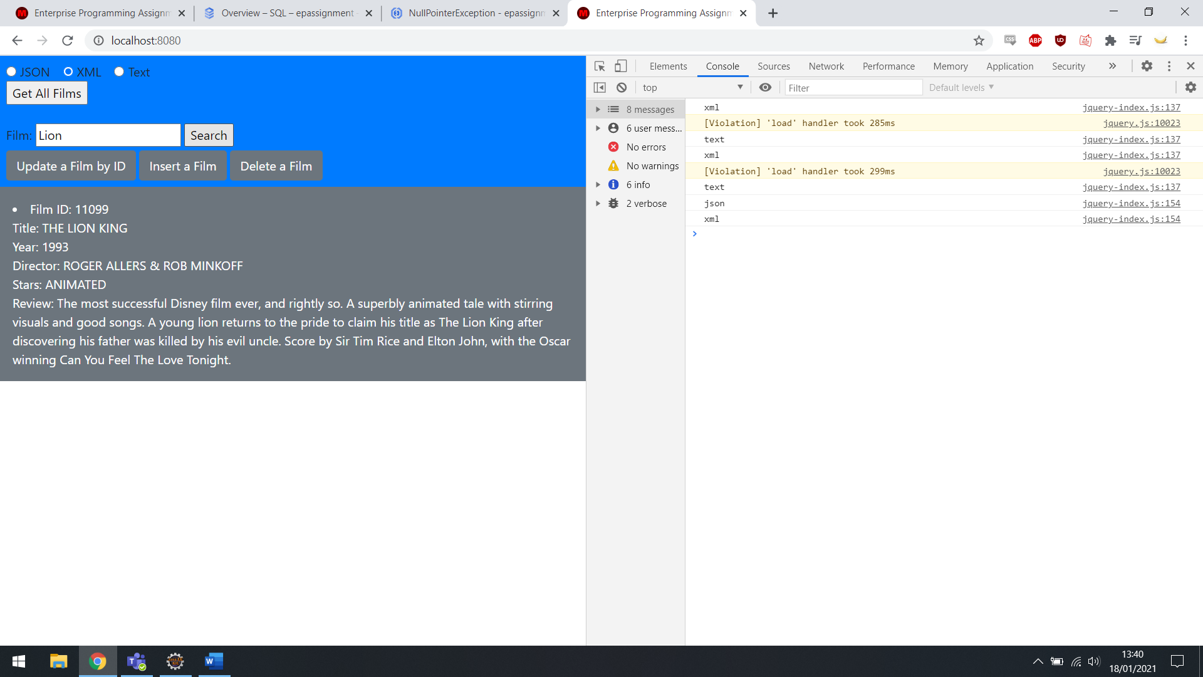

XML Output of Get Film, searched by Lion.

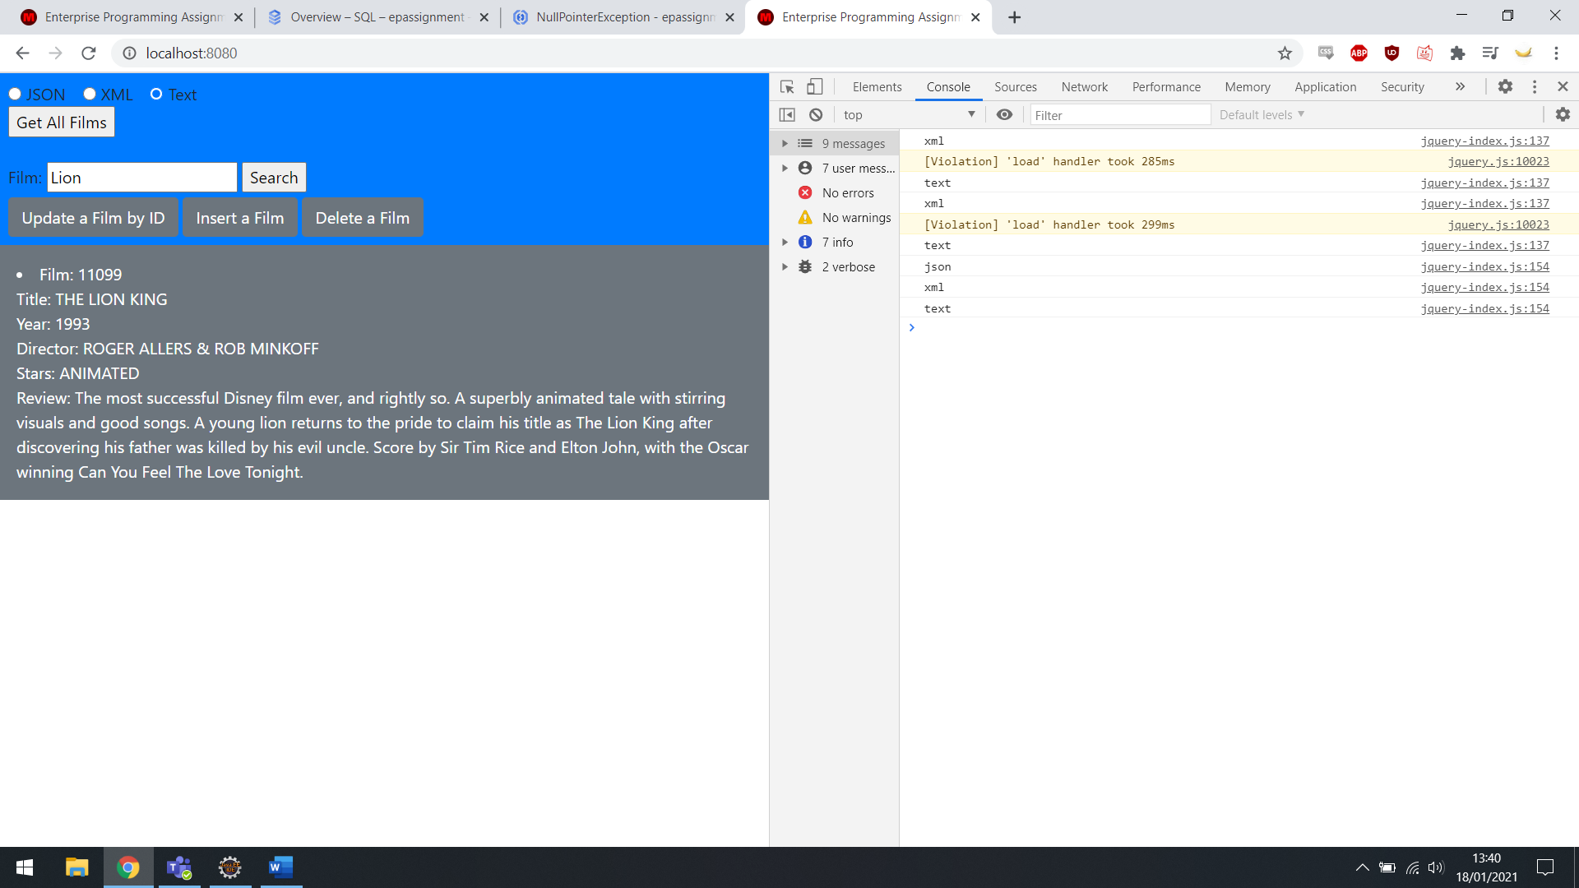

Text Output of Get Film, searched by Lion.

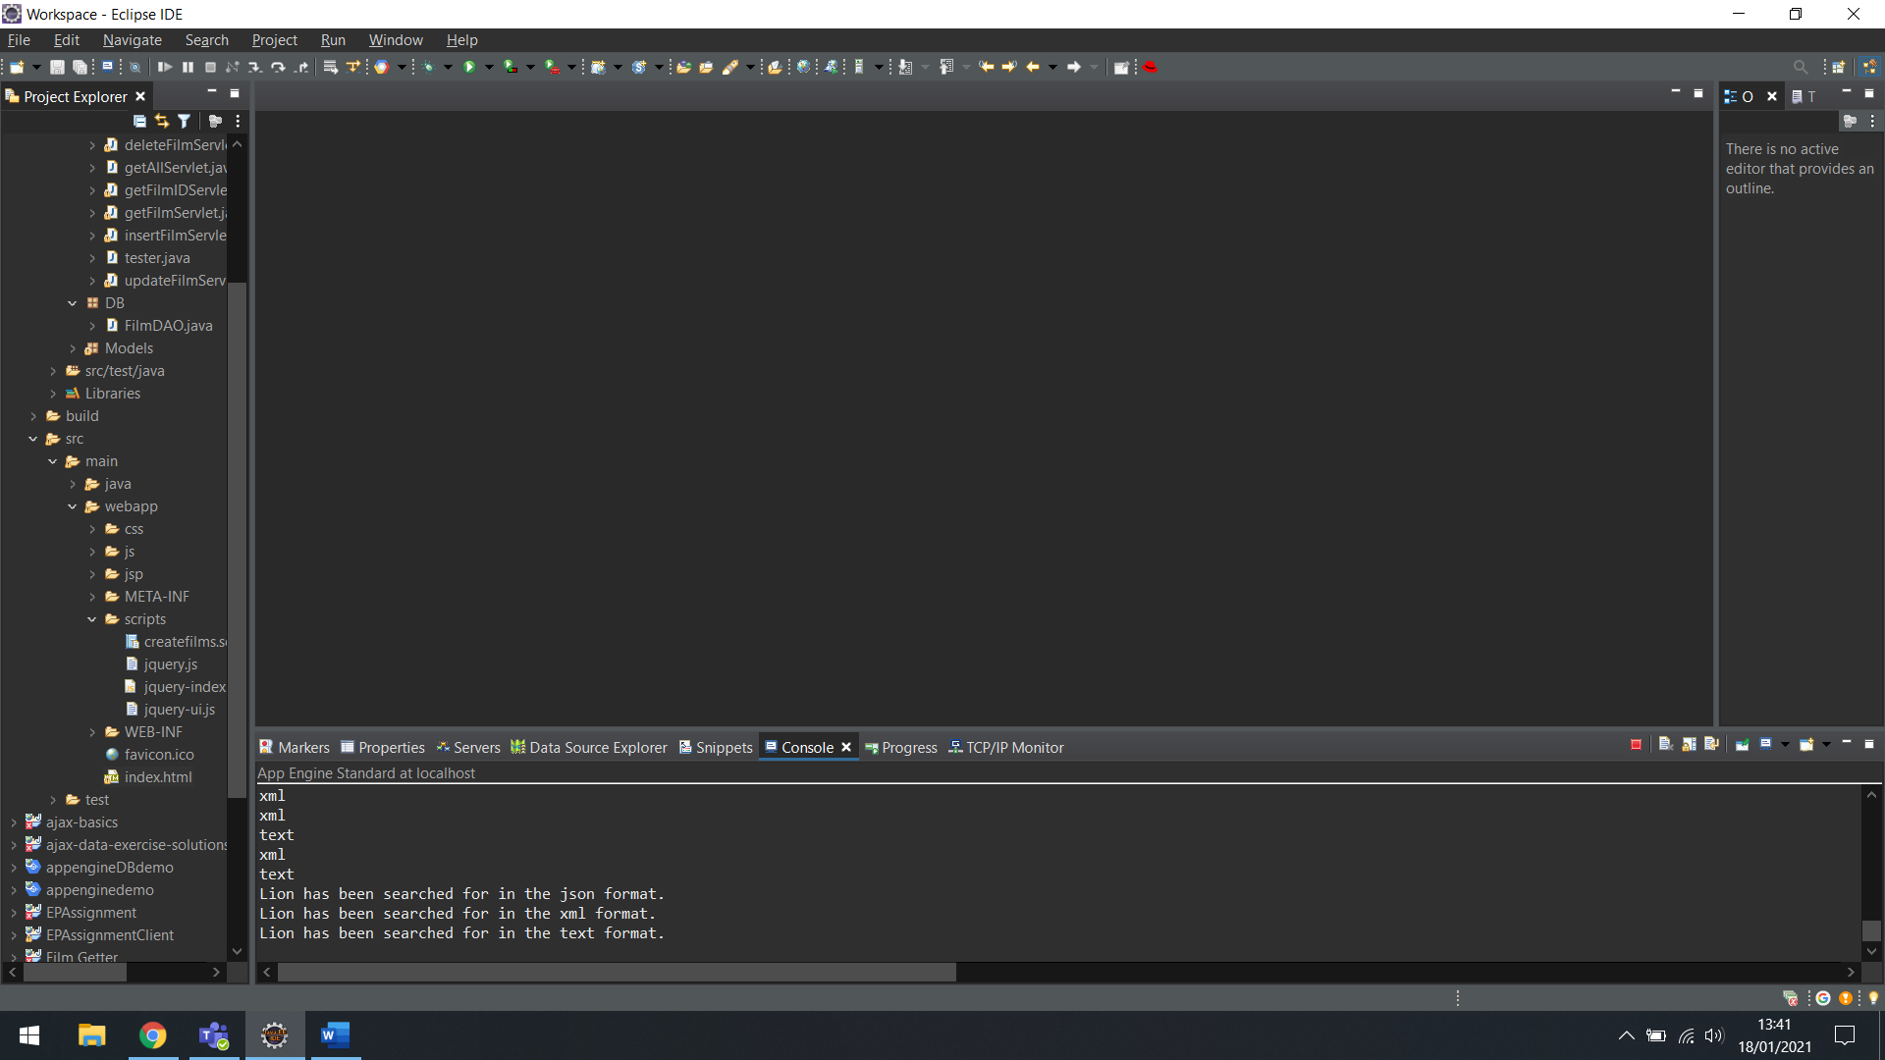Console Output of Get Film, searched by Lion

**Update Film**

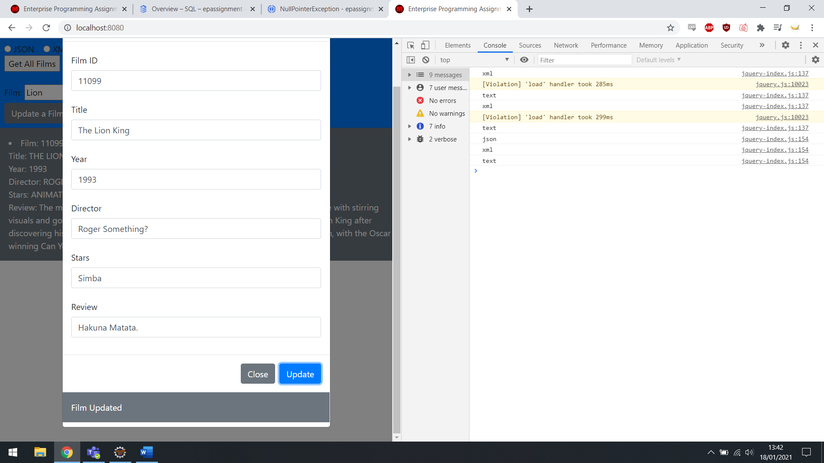

Updating The Lion King.

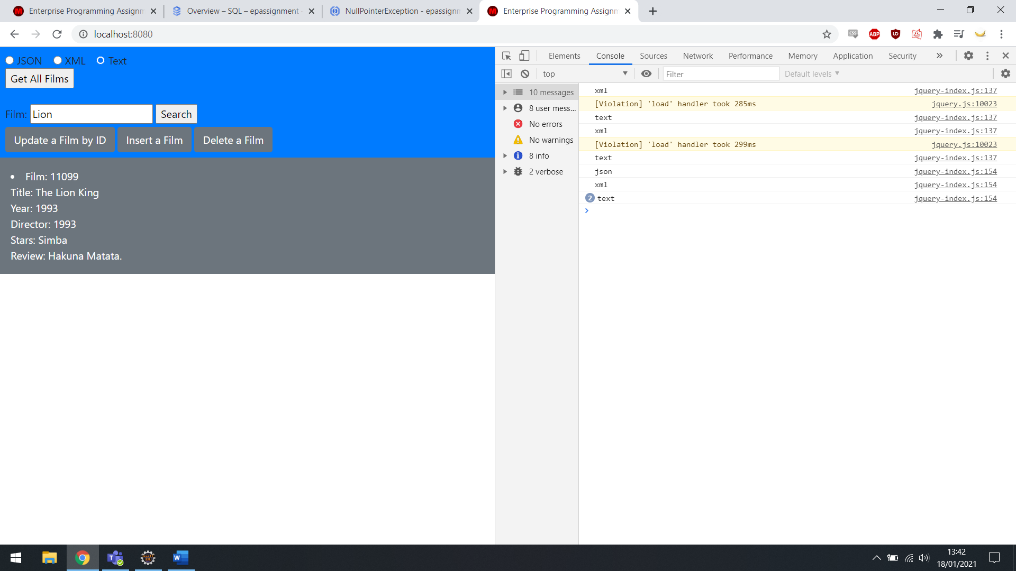

Updates have taken place.

**Insert Film**

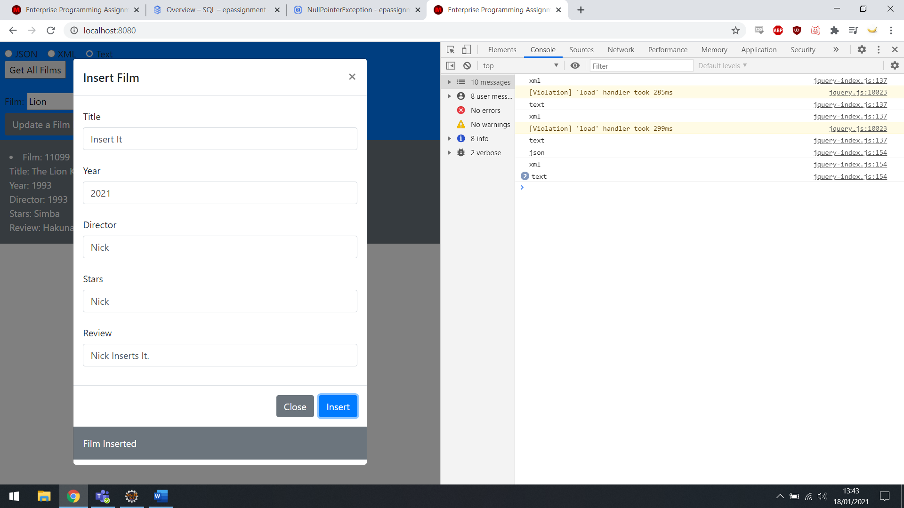

Inserting a test film.

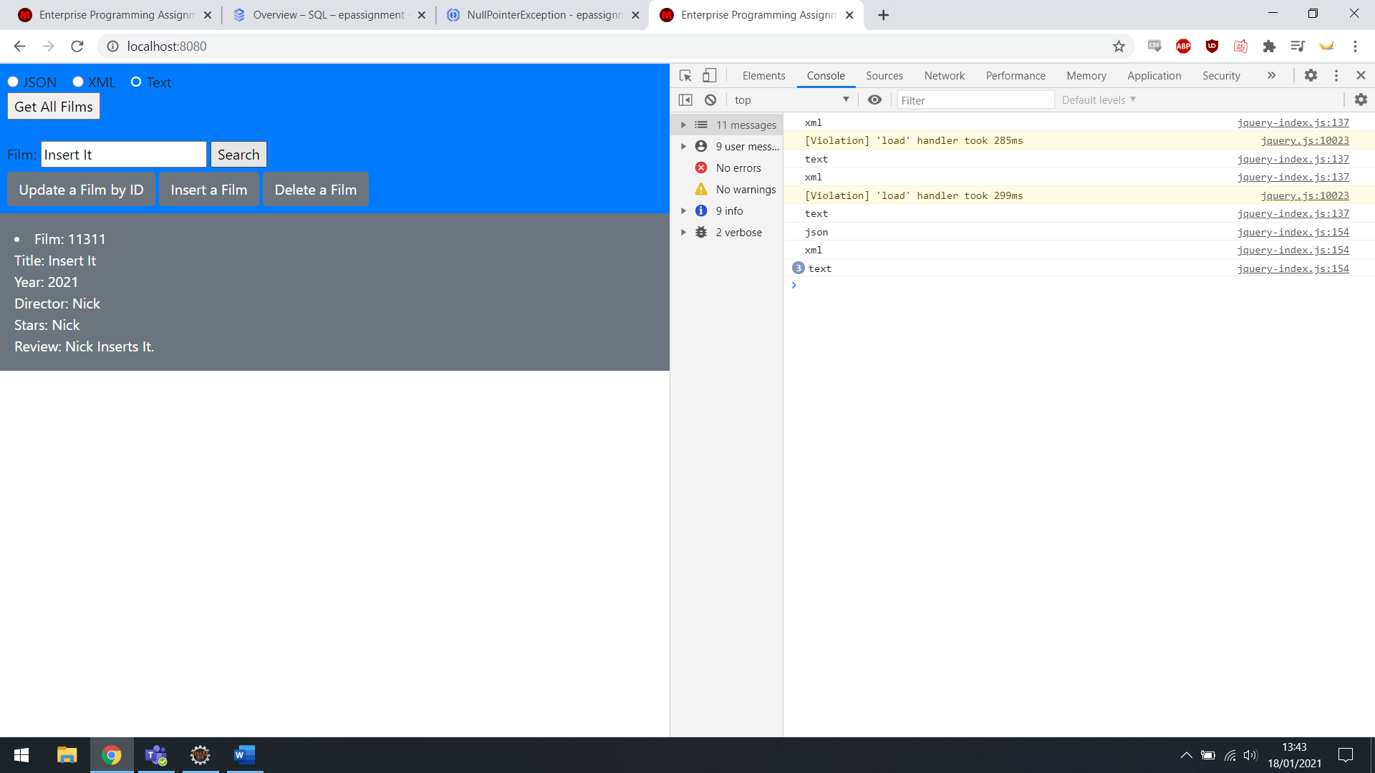

Displaying newly inserted film.

**Delete Film**

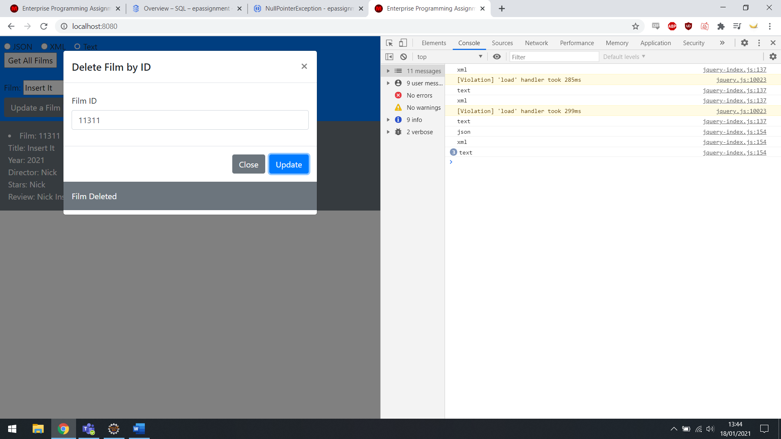

Select newly inserted film to delete.

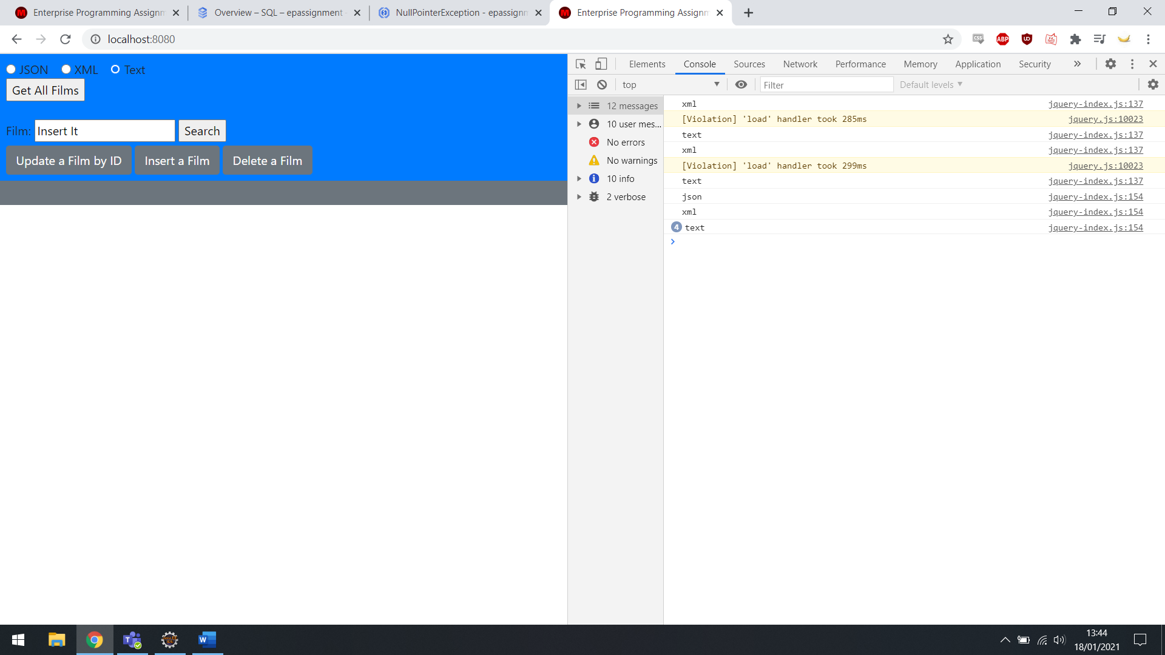

Searched for inserted film, no results.

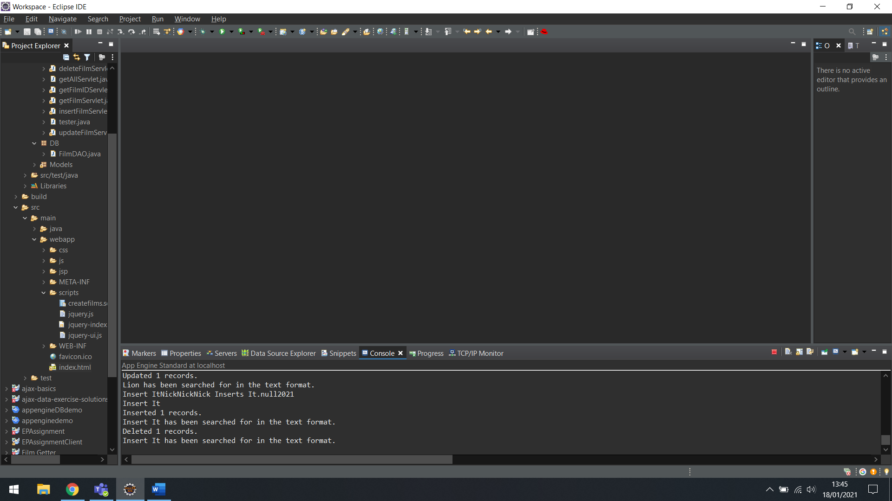

Console Output of Insert/Delete

**Cloud Implementation**

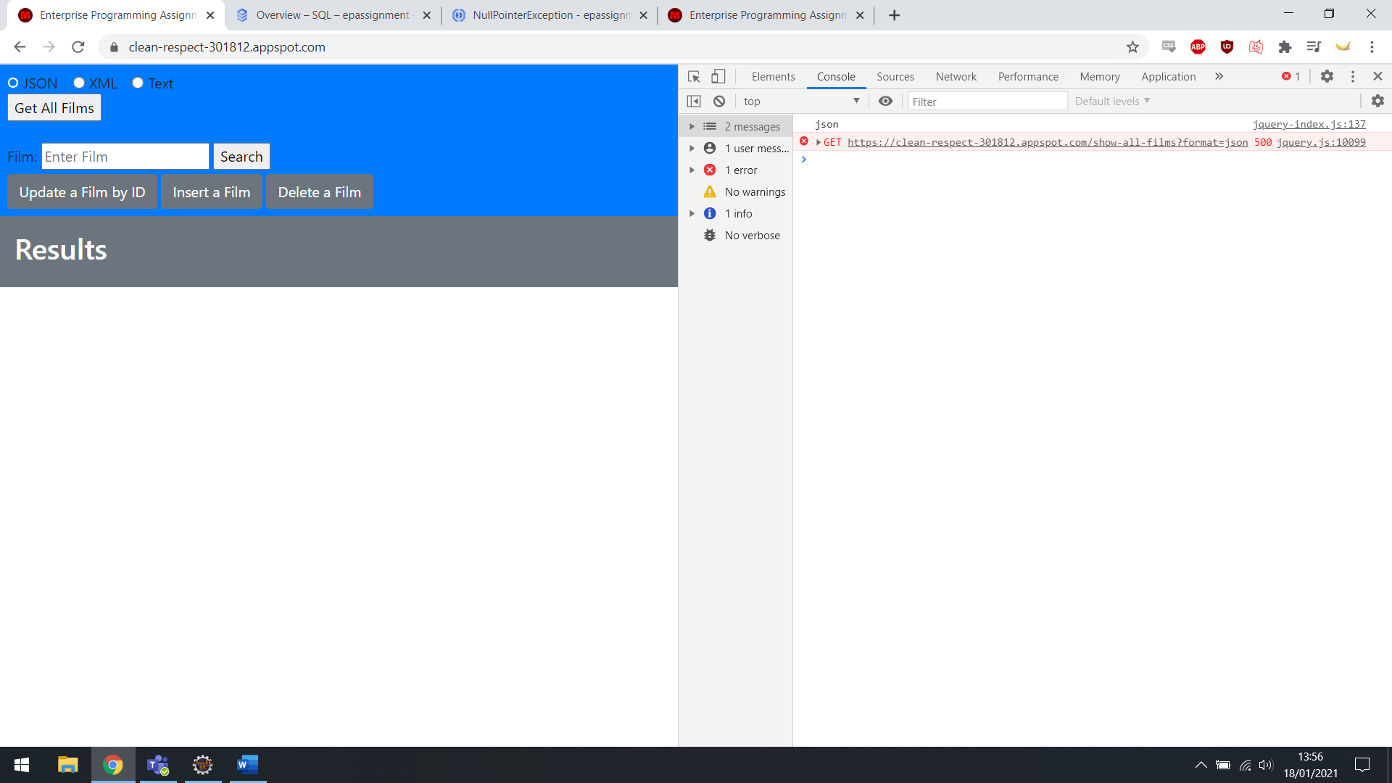

Cloud based web app, with 500 error message.

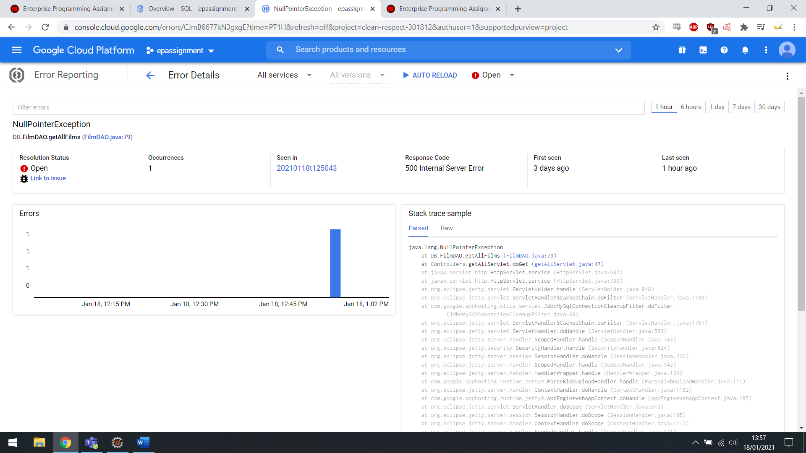

Details of error, was unable to resolve.

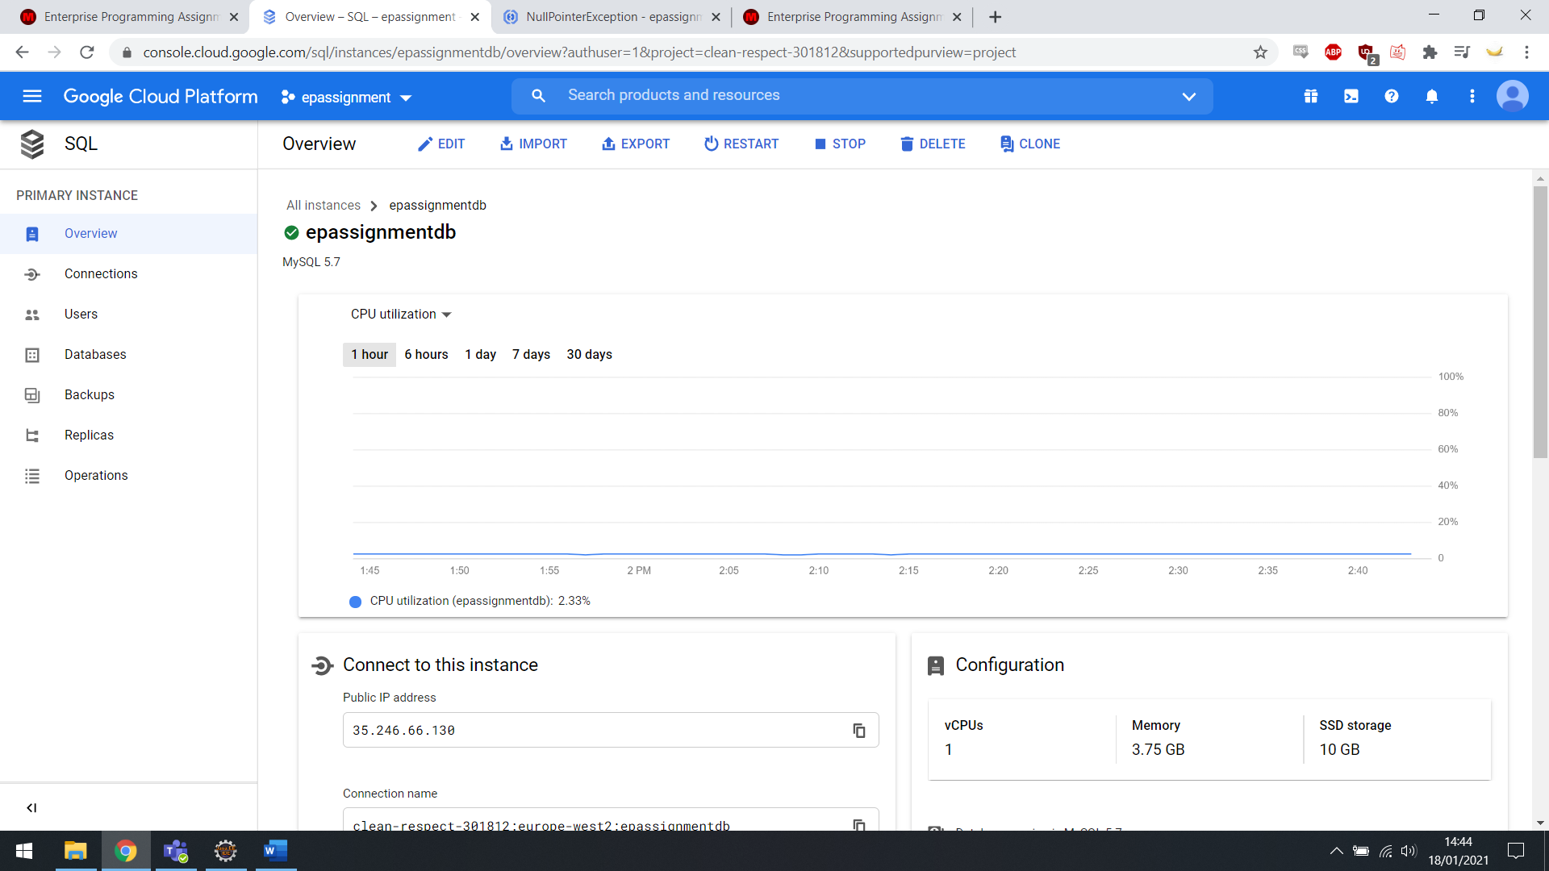

Cloud SQL implementation.

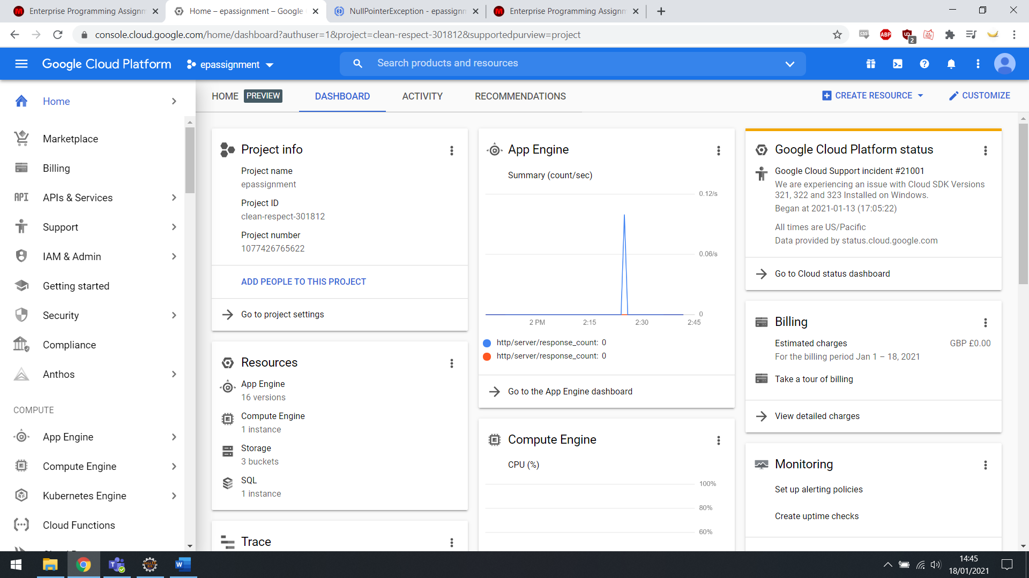

Overview of Cloud Implementation.

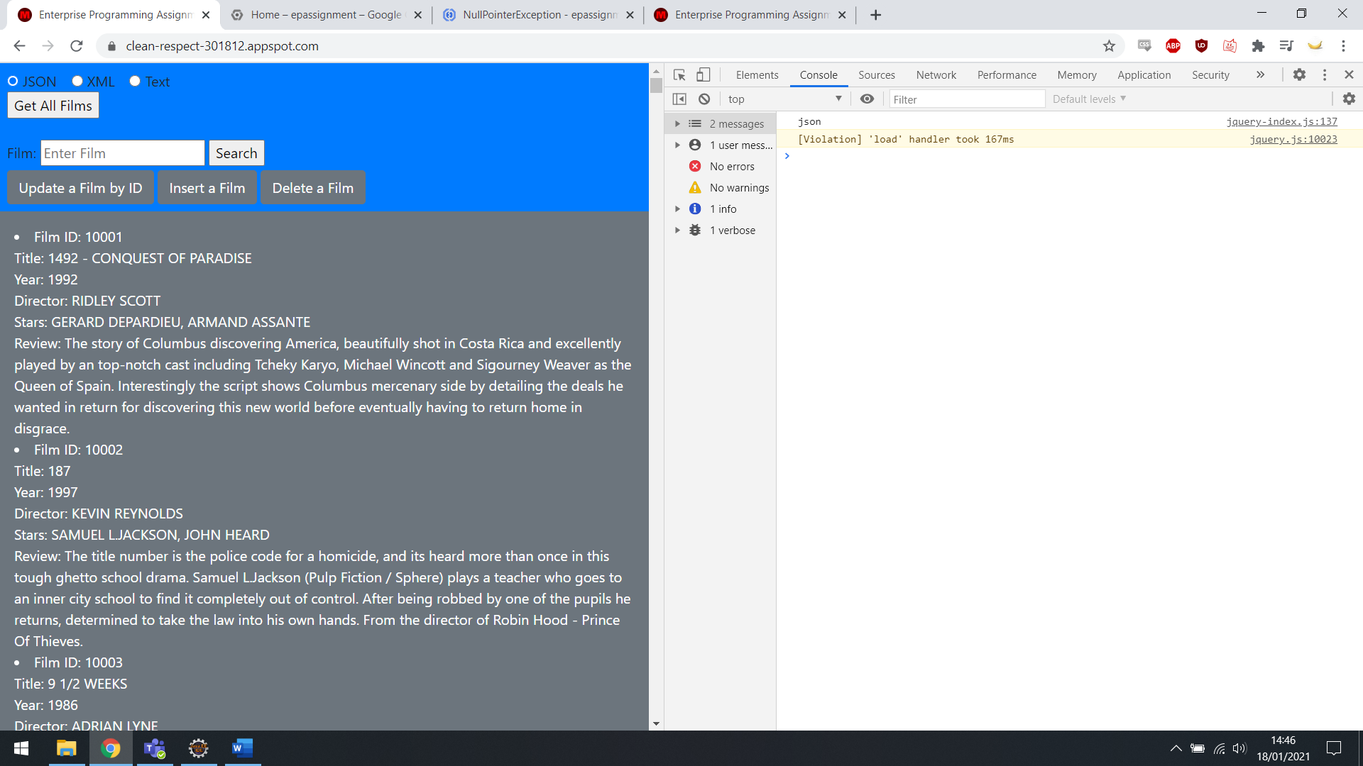

JSON Get All Films, cloud based.

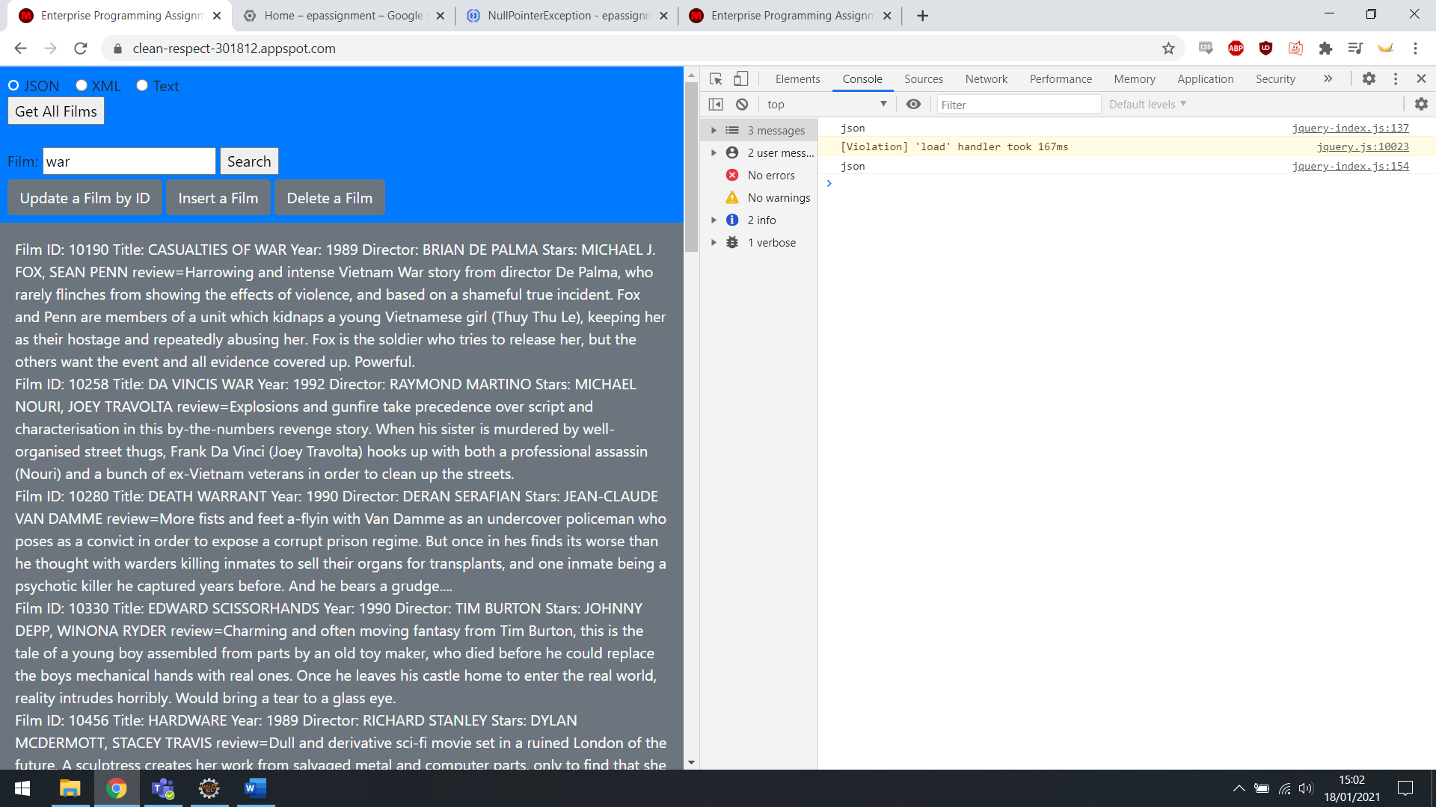

JSON Get Film by war, cloud based.

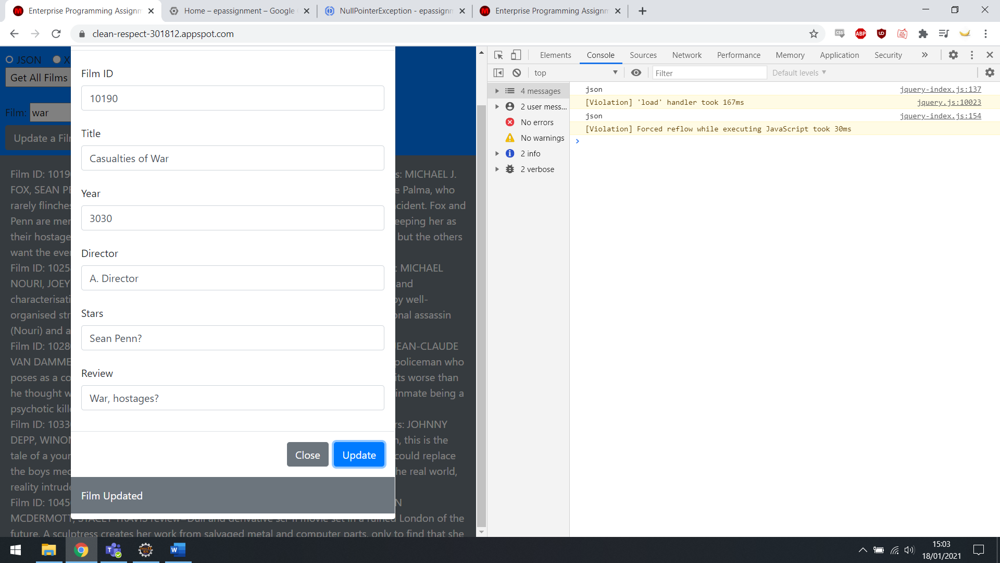

Updating Casualties of War, cloud based.

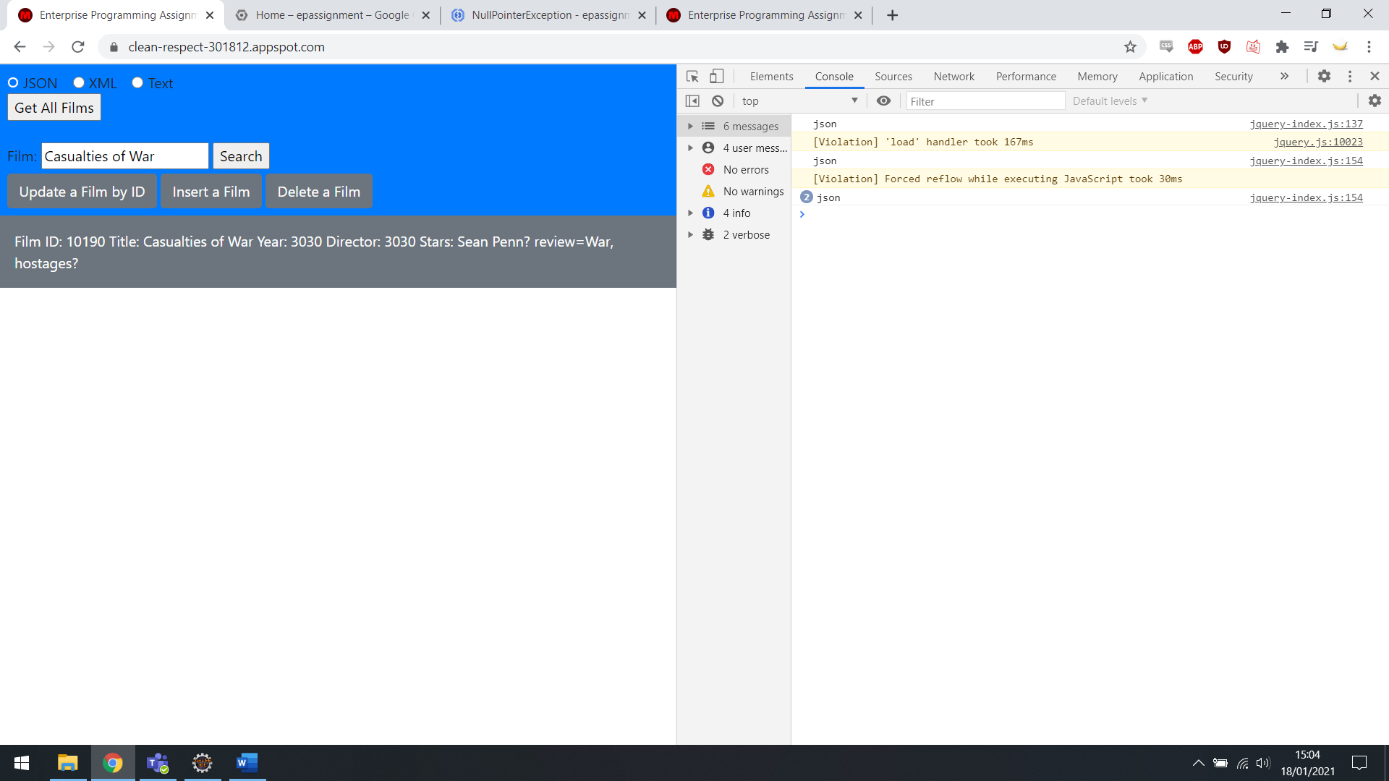

Updated film, cloud based.

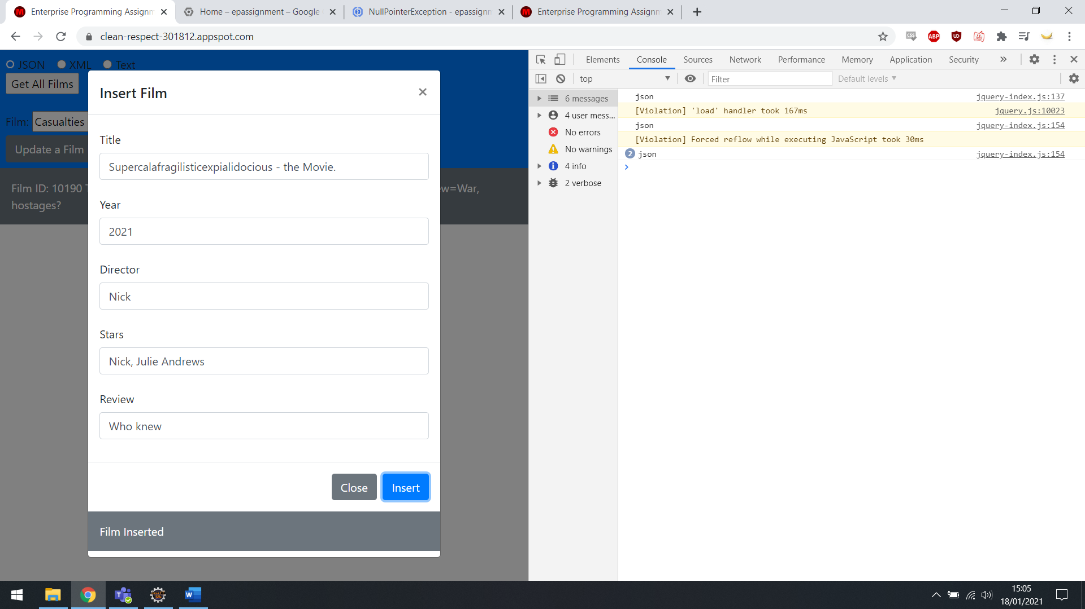

Inserting a test film, cloud based.

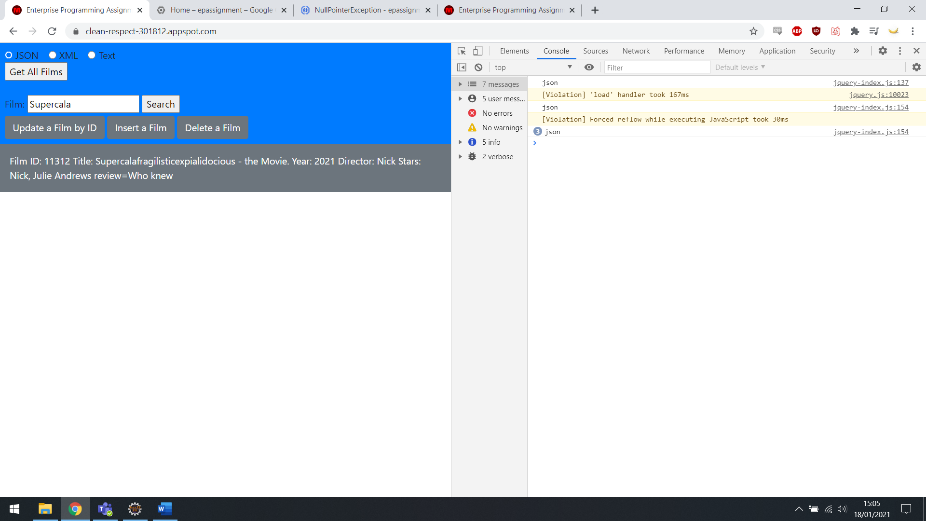

Newly inserted film.

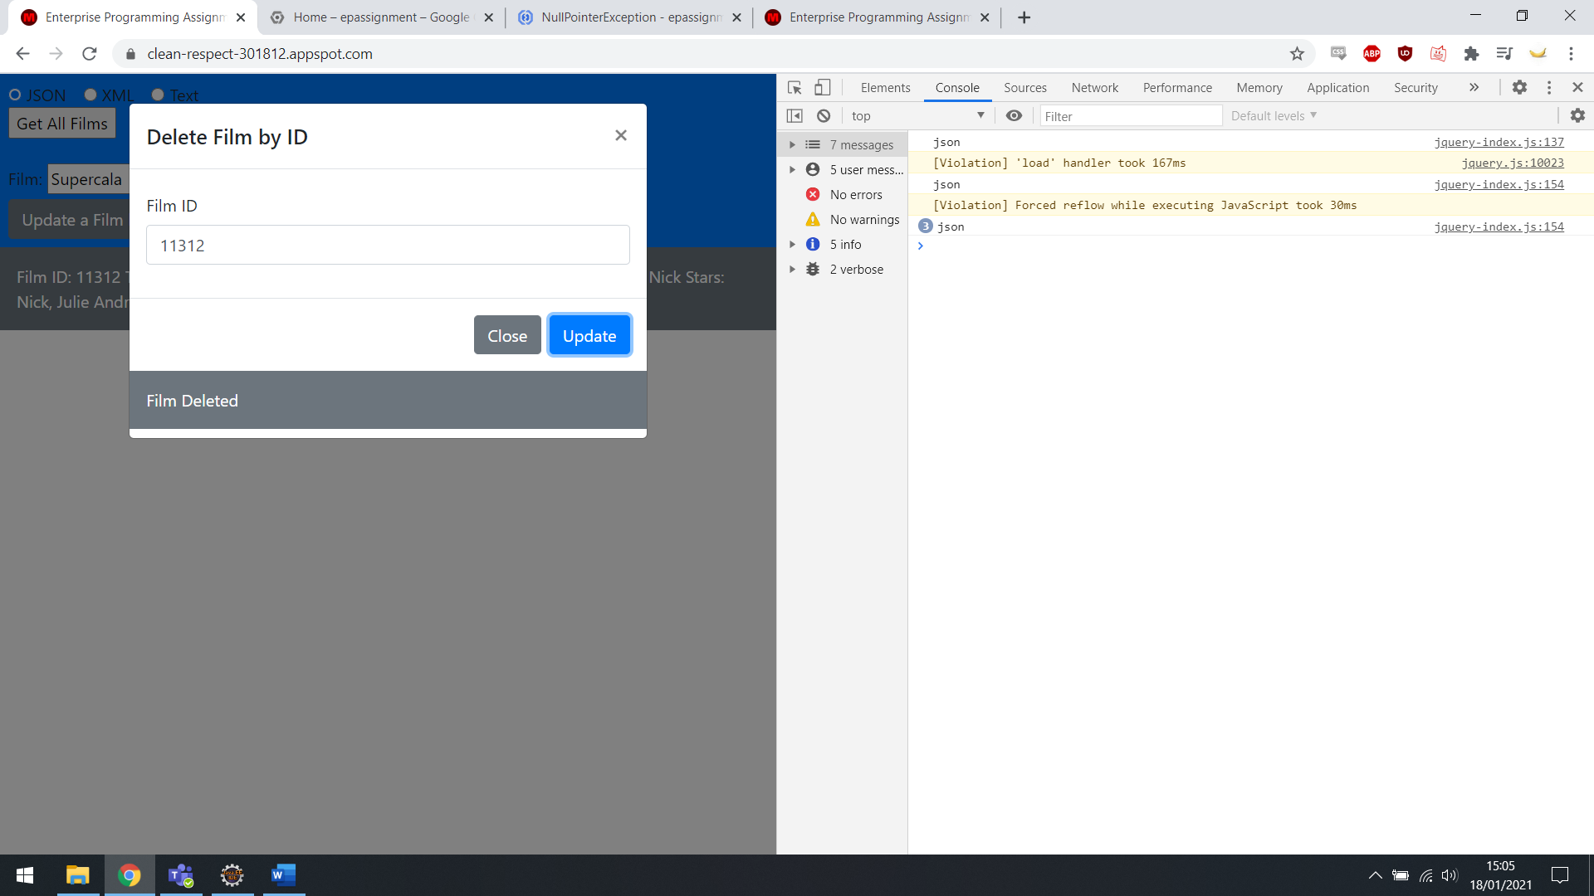

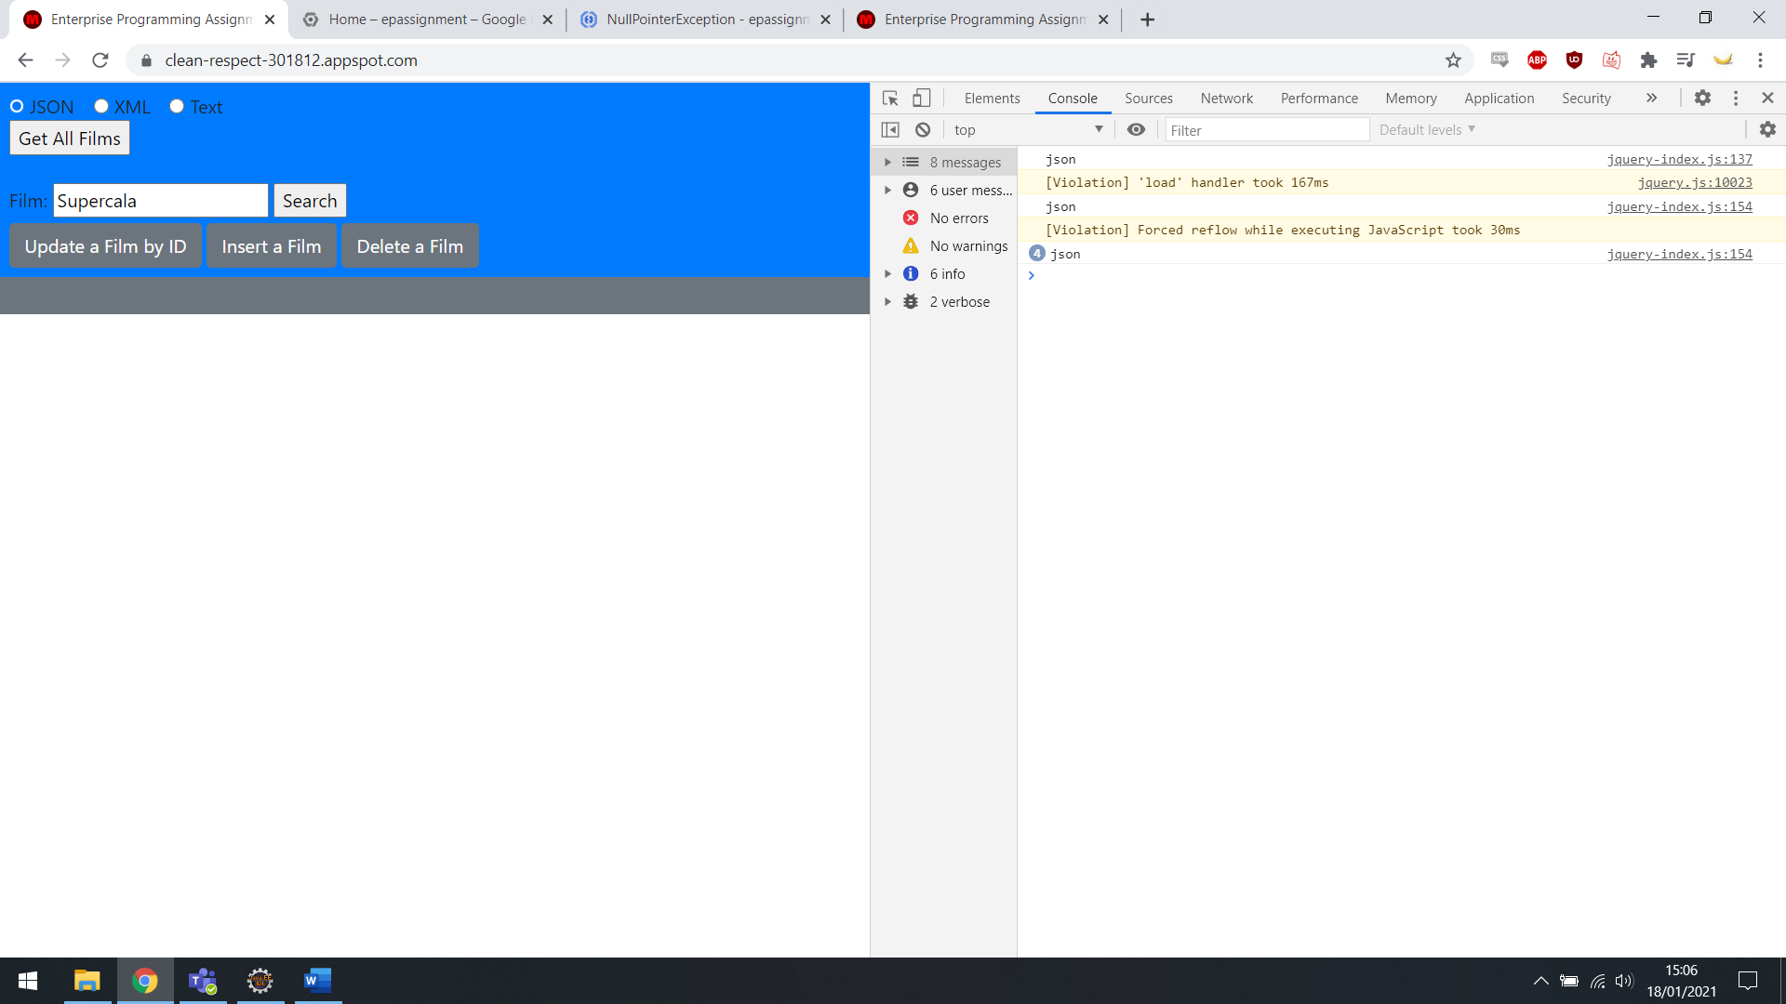

Film now removed, cloud based.

**Analysis**

**Design Patterns**

For the most part, the Singleton design pattern was used within the assignment. This was not a difficult decision, as it is what I am most comfortable with.

Having written the code, and seen an implementation of the Factory pattern, I believe a mix of the two could have saved a lot of work. Several elements within my classes are repeated, and these could have been handled in a Factory manner.

Centralising format/query retrieval, and data output, together would have greatly reduced code size and perhaps readability.

**Refactoring**

The largest part of refactoring carried out within my code was creating a legible flow within every class. Making the sequence of events clear helped debug errors. My formatting was done within my JavaScript/jQuery implementation, other than the string formatting.

**Utilities**

The GSON and JAXB libraries were used to create my JSON and XML data, respectively. My JavaScript was written mostly with jQuery. The website itself uses Bootstrap as CSS, this was chosen due to familiarity from previous work.

The largest benefit of using jQuery was the extensive online documentation/support, and to me, the readability and simple flow of it’s processes.

**Naming**

I attempted to name all classes and variables in a manner that fit their purpose and location in the classes they were part of.

The most repetition occurred within my JavaScript. As I had a number of forms/modals that provided similar information, I had to write a function to retrieve the same data from different places. These each had to be named individually, creation a lot of very similar functions. This could perhaps have been worked around, but getting it working was the priority at the time.